8. Overall Campaign
Mobile Passport Control Launch @ Port Everglades

U.S. Customs and Border Protection (CBP) has had difficulty staffing enough officers to process the growing number of passengers disembarking from the new generation of mega-size cruise ships at Port Everglades and other U.S. cruise ports. Port Everglades serves 3.8 million cruise passengers annually.

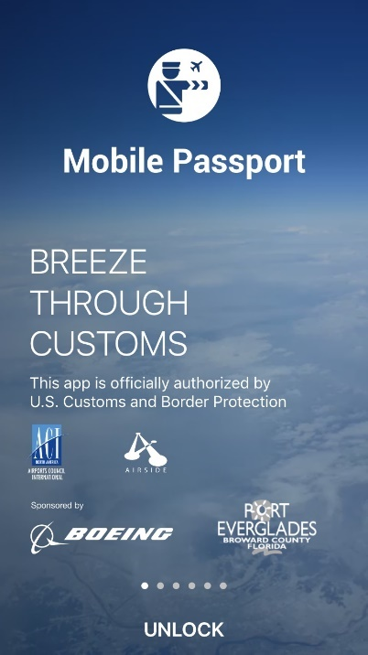
CBP experienced similar problems at international airports in the United States where large numbers of people would disembark international flights arriving at the same time. However, in the case of airports, CBP is using smart phone technology to alleviate congestion through its immigration processing.

A small, private company, Airside Mobile, worked with the Airports Council International trade organization to develop and execute a phone app called Mobile Passport Control (MPC). CBP has accepted its use at airports across the United States and has gained popularity among travelers.

Until November 2016, MPC was only available in airports. However, Port Everglades officials worked with Airside Mobile, the CBP and the port’s cruise line customers to bring MPC to the cruise market. In November 2016, with the arrival of the world’s largest cruise ship Harmony of the Seas, Port Everglades became the first and only cruise port in the United States to offer MPC.

1. What are/were the entry’s specific communications challenges or opportunities?

The challenge for Port Everglades staff was to inform passengers about this new service and encourage them to try it. There was also the opportunity to reach the nearly 2 million cruise passengers who disembark from ships with news that Port Everglades was using cutting edge technology to improve customer service.

2. How does the communication used in this entry complement the organization’s overall mission?

Port Everglades Mission Statement:
Port Everglades is Florida’s powerhouse global gateway. A respected leader in trade, travel and financial stability, we create economic and social value by working in partnership with world-class clients. We achieve advancements focusing on efficient facilities, trade and cruise expansion, jobs growth, safety, security and environmental stewardship for our customers, stakeholders and community.

The key phrases from our mission statement that influenced the MPC project are:

“A respected leader” – Port Everglades is the only cruise port in the United States to offer the Mobile Passport Control app.

“We achieve advancements focusing on efficient facilities” – Port Everglades is using cutting-edge technology to improve processing wait times for cruise guests.

3. What were the communications planning and programming components used for this entry?

The goal of this project was to reduce processing wait times for cruise passengers disembarking from returning ships.

The objective was to get cruise passengers to download and use the MPC app.

The audiences, in order of importance are:
- Cruise passengers -- The primary users. Port Everglades services 3.8 million embarking, debarking and port-of-call cruise passengers annually. Approximately 2 million debarking U.S. passengers have the opportunity to use the app.
- Cruise lines – As the port’s customers, we wanted them to help us spread the word to their guests. And, secondarily to recognize that the port was doing something to benefit their passengers and improve customer service. This may benefit the port when the cruise line is deciding where to homeport their ships.
- Media – As a conduit to spreading the word. Social media played a major role.

4. What actions were taken and what communication outputs were employed in this entry?

To launch the app and spread the word, all Port Everglades Corporate Communications and Cruise Marketing staff got involved. There are four people in Corporate Communications and three Cruise Marketing staff, plus the Port’s Chief Executive, Deputy Port Director and the Business Development Director. We also worked with Royal Caribbean’s public relations staff to communicate to passengers already aboard arriving ships. The Port’s internal sign shop printed signs.

Test Phase:
Port officials worked with Airside Mobile, CBP and cruise lines to test the MPC app throughout the summer so that the official launch would coincide with the arrival of the world’s largest cruise ship, Royal Caribbean International’s Harmony of the Seas, in November 2016.
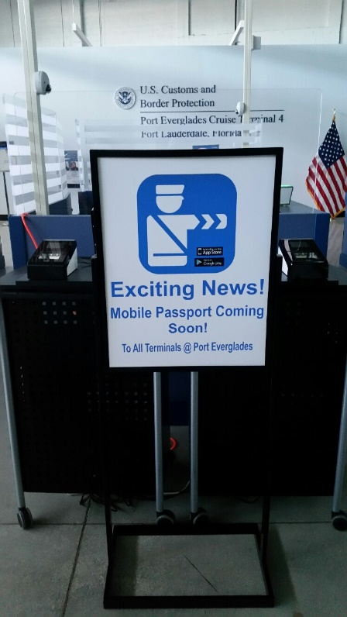
In a press release announcing the test phase for MPC and another pilot program, CBP Port Director Jorge Roig said: "We are very fortunate to be able to partner with Port Everglades in innovative projects that will enhance the arriving passengers' experience. These important business transformation initiatives are part of CBP's greater resource optimization strategy and will help to support the increased passenger traffic growth that we continue to see in South Florida."

Pre-launch:
Signs were created to inform guest of the app when they came into the luggage hall and debark area.

Cruise line shore managers received a firsthand demonstration of the app to instruct their staffs.

A press release was distributed to cruise industry media on June 21, 2016, announcing the pilot project.

The press release was also sent to key travel agencies and organizations.

Social media announcements about the pilot were posted on Facebook and Twitter.

The port’s newsletter, Smooth Sailings, included an announcement.

Cruise marketing staff promoted MPC during trade shows with travel agents.

Launch:

Royal Caribbean’s Harmony of the Seas became the launch site for the new MPC app.

  - MPC was advertised during all the promotional cruises through the onboard newsletter and during disembarkation announcements. (see attachment)

  - Royal Caribbean hosted several press events where MPC was promoted.

  - Royal Caribbean shore staff was trained to encourage passengers to download the MPC.

  - A special email was sent to a press group of “influencers” who sailed during a promotional cruise. These bloggers were encouraged to try the app when they disembarked.

Port Everglades distributed a press release on November 2, 2016, to local media, cruise industry media, travel agencies, chambers of commerce and general port publications/media.

Social media announcements about the launch were posted on Facebook and Twitter. (see attachments)

We also continue to promote the MPC app on Facebook and Twitter.

Announcements were included in the port’s eNewsletter, the weekly newsletter Smooth Sailings and online.

MPC is promoted in the Port’s Cruise Guide, Facilities Directory and on the website.

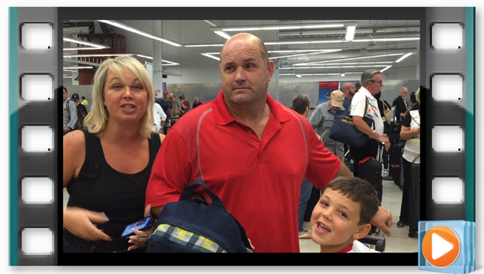

https://www.facebook.com/port.everglades/videos/1220815534623563/
1.2K views

5. What were the communications outcomes from this entry and what evaluation methods were used to assess them?

To date, there are approximately 4 million members of the MPC app.

Roughly 20 percent of all U.S. passengers disembarking at Port Everglades are using the app..

Wait times to clear Customs have been reduced by 60 to 90 minutes.

Articles were published in news and trade publications, in print and online. (see attachment)

Strong appeal in social media. (see attachment)

